**A**

**PROJECT REPORT**

**On**

**LPG GAS LEAKAGE DETECTOR ALARM USING ARUDINO.**

*SUBMITTED IN PARTIAL FULFILLMENT OF THE REQUIREMENT FOR*

*THE AWARD OF DIPLOMA*

**IN**

**ELECTRONICS & COMMUNICATION ENGINEERING.**

**SUBMITTED BY**

18253-EC-062 E.AJAYKUMAR

18253-EC-080 ABC.AKHIL

18253-EC-089 D.SHRAVYA

18253-EC-096 G.KAMAL RAJ

18253-EC-119 S.CHANDRAKANTH

**UNDER THE GUIDANCE OF: A.PADMAVATHI Lecturer**

**Department of Electronics &Communication Engineering**

**VNRVJIET**



**2nd SHIFT POLYTECHNIC**

**DIPLOMA IN ELECTRONICS & COMMUNICSATION ENGINEERING**

**VALLURUPALLI NAGESWARA RAO**

### VIGNANA JYOTHI INSTITUTE OF ENGINEERING AND TECHNOLOGY

### PRAGATHI NAGAR, BACHUPALLY, NIZAMPET (S. O),

**HYDERABAD - 500 090**

**2020– 2021**

**2ndSHIFT POLYTECHNIC**

**VALLURUPALLI NAGESWARA RAO VIGNANA JYOTHI**

**INSTITUTE OF ENGINEERING & TECHNOLOGY**



# CERTIFICATE

This is to certify that the project report entitled **“LPG GAS LEAKAGE DETECTOR ALARM USING ARUDINO”** has been carried out at VNR VJIET, Hyderabad and submitted by the following students.

18253-EC-062 E.AJAYKUMAR

18253-EC-080 ABC.AKHIL

18253-EC-089 D.SHRAVYA

18253-EC-096 G.KAMAL RAJ

18253-EC-119 S.CHANDRAKANTH

In partial fulfillment of the requirements for the award **of Diploma in Electronics &Communication Engineering** to **State Board of Technical Education and Training, Telangana** at **VNR Vignana Jyothi Institute of Engineering & Technology** during the period of 2020-2021, he/she carried out a bonafide work under the guidance and supervision of the under signed. The results embodied in this project report have not been submitted to any another University or institute for the award of any Degree.

## A.PADMAVATHI Dr.Y.PADMA SAI

## Lecturer Head of the Department

Electronics and Communication Electronics and communication

Engineering Engineering

VNR VJIET VNR VJIET

**APPROVAL CERTIFICATE**

Viva–Voice examination conducted for the dissertation work entitled **“LPG GAS LEAKAGE DETECTOR ALARM USING ARUDINO**”

18253-EC-062. E. AJAYKUMAR

18253-EC-080 ABC.AKHIL

18253-EC-089 D.SHRAVYA

18253-EC-096 G.KAMAL RAJ

18253-EC-119 S.CHANDRAKANTH

Is conducted on the work is approved for the award of degree of Diploma in **Electronics& Communication Engineering**

**Internal Examiner** **External Examiner**

# ACKNOWLEDGEMENT

Our sincere thanks to **Mrs. A.PADMAVATHI**, Department of Electronics and Communication Engineering, 2nd SHIFT POLYTECHNIC, VNR VJIET, who motivated us during project work, guiding us throughout inspire of her schedules and commitments.

We also thankful to **Dr. G.VIJAY KUMAR**, Assistant Professor & Co-coordinator of DECE, VNR VJIET, Hyderabad, for extending support to provide project work.

Our Sincere thanks to **Dr. Y.PADMA SAI** Head of the Department, Electronics and

Communication Engineering, VNR VJIET & all the faculty of the Department for the encouragement and guidance provided.

We extend our sincere thanks to **Dr. B.SATYANARAYANA,** Vice Principal, 2ndpolytechnic, VNR VJIET, Hyderabad, for shift his help & co-operation in providing support for project work.

A special note of thanks to **Dr.C.D.NAIDU**, Principal, VNRVJIET and management of VNRVJIET for providing facilities for project work.

We sincerely thank all of them who have helped me either directly or indirectly during the completion of the project tenure.

18253-EC-062 E.AJAYKUMAR

18253-EC-080 ABC.AKHIL

18253-EC-089 D.SHRAVYA

18253-EC-096 G.KAMAL RAJ

18253-EC-119 S.CHANDRAKANTH

**Place: Bachupally**

**Date:**

# DECLARATION

We do declare that this work entitled “**LPG GAS LEAKAGE DETECTOR ALARM USING ARDUINO**” submitted in the department of Electronics and Communication Engineering Vallurupalli Nageswara Rao Vignana Jyothi Institute of Engineering & Technology, Hyderabad, in partial fulfillment of the requirement for the award of the Diploma in Electronics and Communication is a bonafide record of our own work carried out under the supervision of **Mrs.A.PADMAVATHI**.

Also, we declare that the matter embodied in this thesis has not been submitted by us in full or any part thereof for the award of any degree /diploma of any other institute or university previously.

18253-EC-062 E.AJAYKUMAR

18253-EC-080 ABC.AKHIL

18253-EC-089 D.SHRAVYA

18253-EC-096 G.KAMAL RAJ

18253-EC-119 S.CHANDRAKANTH

**Place: Bachupally**

**Date:**

# ABSTRACT

LPG gas is one of the most important need in the world when it comes for cooking. It is used in household's, restaurants in mall's and soon. It is useful but also dangerous due to its ability of catching fire immediately with a spark of fire to a terrible fire accident . So, For the safety of people who are working with it(or) near to it we came up with an innovative project i.e., "LPG gas leakage detector alarm using Arduino nano".



So, when ever any leakage of LPG gas takes place then at that time the mq-135 sensor will give a signal to Arduino nano to make the alarm (or) buzzer to get into active state which will intimate that gas leakage has taken place to move away from it. Hence, This project is suitable for use in places such as restaurants, household's and in mall's etc. It can help in reducing" LPG fire accidents and save life's"

Contents

Name of the chapter Page no

ACKNOWLEDGEMENT I

DECLARATION II

ABSTRACT III

CHAPTER 1 INTRODUCTION 1

CHAPTER 2 COMPONENTS DESCRIPTION 3

2.1 Arduino Nano 3

2.1.1 - PIN DESCRIPTION 4

2.1.2- FEATURES 6

2.2 MQ-135 SENSOR 7

2.2.1- PIN DESCRIPTION 8

2.2.2- Features 9

2.3 LEDS 10

2.3.1 - Pin Description 11

2.3.2 - Working Principle 11

2.3.3 - Features and Technical Specifications 11

2.3.4 – Advantage 12

2.3.5 – Applications 12

2.4 BUZZER 13

2.4.1 - Buzzer Pin Description 14

Table 1.3:- pin configuration of Buzzer 14

2.4.2 - Buzzer Features and Specifications 14

2.5 BREAD BOARD 15

2.6 CONNECTING WIRES & JUMPER WIRES 17

2.6.1 – SINGLE STAND CONNECTING WIRES 17

2.6.2 – JUMPERWIRES 17

2.7 9V BATTTERY 21

CHAPTER 3 SOFTWARE DESCRIPTIOIN 22

CHAPTER 4 WORKING 29

4.1 BLOCK DIAGRAM EXPLANATION 29

4.2 CIRCUIT EXPLANATION 30

4.3 WORKING 31

4.4 ADVANTAGES 31

4.5 APPLICATIONS 32

CHAPTER 5 RESULT 33

CHAPTER 6 CONCLUSION & FUTURE SCOPE 34

6.1 CONCLUSION 34

6.2 FUTURE SCOPE 34

CHAPTER 7 APPENDIX 35

CHAPTER 8 REFERENCES 37

**LIST OF FIGURES PAGE NO**

FIG 1.0 – ARDUINO NANO 3

FIG 1.1 – ARDUINO NANO PINOUT 4

FIG 1.2 - MQ-135 SENSOR 7

FIG 1.3 – MQ-135 PIN OUT 7

FIG 1.4 – GREEN LED 10

FIG 1.5 – RED LED 10

FIG 1.6 – LED PINOUT 10

FIG 1.7 – BUZZER 13

FIG 1.8 – BUZZER PINOUT 13

FIG 1.9 – BREAD BOARD 15

FIG 2.0(a) – INTERNAL STRUCTURE OF BREAD BOARD 15

FIG 2.0(b) – SERIAL CONNECTION IN BREAD BOARD 16

FIG 2.0(c) – PARALLEL CONNECTION IN BREAD BOARD 16

FIG 2.1 – SINGLE STANDS WIRE 17

FIG 2.2 – JUMPER WIRES 18

FIG 2.2(a) – JUMPER WIRES WITH CROCODILE CLIPS 18

FIG 2.2(b) – MALE TO FEMALE CONNECTORS 19

FIG 2.2(c) – MALE TO MALE CONNECTORS 20

FIG 2.3 – 9V BATTERY WITH CONNECTOR 21

FIG 2.4 – A TO B CONNECTOR 22

FIG 2.5 – DOWNLOADING ARDUINO IDE 23

FIG 2.6 – LAUNCH ARDUINO IDE 24

FIG 2.7 – TO CREATE A NEW PROJECT 25

FIG 2.7(a) – OPENING PROJECT 25

FIG 2.8 – SELECTING ARDUINO BOARD 26

FIG 2.9 – SERIAL PORT SELECTION 27

FIG 3.0 – UPLOADING PROGRAM 28

FIG 3.1 – BLOCK DIAGRAM 29

FIG 3.2 – CIRCUIT DIAGRAM 30

FIG 3.3 – CIRCUIT CONNECTION 31

FIG 3.4 – OUTPUT OF PROJECT 32

**Tables page no**

Table 1.0:-pin configuration of Arduino nano 4

#### Table 1.1:- pin configuration of MQ -135 sensor 7

#### Table 1.2:- pin configuration of LED 11

#### Table 1.3:- pin configuration of Buzzer 14

# CHAPTER 1

# INTRODUCTION

In early days our elders used wood as firing element for cooking. Wood is a good flaming material which is one of the one of the gifts of nature. As time passes away the usage of wood also increased due to which the deforestation increased not only that by burning wood CO2 in released into air causing pollution. To stop this later they discovered LPG (liquefied petroleum gas) which is also a very good flaming agent. Advantage of LPG is it does not produce any pollution while burning and can be used for cooking.

LPG is the abbreviation or short form for liquefied petroleum gas. Like all fossil fuels, it is a non-renewable source of energy. It is extracted from crude oil and natural gas. The main compositions of LPG are hydrocarbons containing three or four carbon atoms. The normal components of LPG thus, are propane (ClHa) and butane (CaHro). Small concentrations of other hydrocarbons may also be present. Depending on the source of the LPG and how it has been produced, components other than hydrocarbons may also be present.

LPG is highly inflammable and must therefore be stored away from sources of ignition and in a well-ventilated area, so that any leakage can disperse safely. LPG vapors is heavier than air so care should be taken during storage so that any leakage will not sink to the ground and get accumulated in an area which is low lying and difficult to disperse.

LPG gas is basically propane and butane and it is odorless in its natural state. The smell that we notice when there is a leakage is actually of an entirely different agent, called Ethyl Mercaptan. This substance is added to the gas when it leaves the main storage terminals. The objective of this project is to detect leakage of LPG in home, hotels, schools and other domestic areas. It will detect the leakage and will give sound signals to alert the people around.

Gas sensors are nowadays being used in wide range of applications in the field like safety, health, instrumentation etc. This project is an implementation of the same using MQ-135 gas sensor. The MQ-135 sensor is commonly used for detecting gas leakage, smoke detecting for various applications.

The MQ-135 gas sensor detects the concentration of gas in ppm and outputs analog value which can be converted to a digital signal using inbuilt Analog to Digital Convertor of Arduino nano.

Then the signal is provided to the LED and buzzer (audio signaling device) when will act as an alarm & intimates the user or people around it to move to safe place i.es leakage of LPG has taken place you should move away from it.

This project of ours can be used in different places like houses, hotels, restaurants, LPG gas stations……so on. It provides safety and can make you work better without any tension and fear.

# CHAPTER 2

# COMPONENTS DESCRIPTION

## 2.1 Arduino Nano

The Arduino Nano is a small, complete, and breadboard-friendly board based on the ATmega328P. It offers the same connectivity and specs of the Arduino Uno board in a smaller form factor. The Arduino Nano is programmed using the Arduino Software integrated development environment (IDE), which is common to all Arduino boards and running both online and offline. We can tell our board what to do by sending a set of instructions to the microcontroller on the board' to do so you use the Arduino programming language (based on wiring), and the Arduino software (lDE) based on processing. The Arduino software is easy-to-use for beginners, yet flexible enough for advanced users.

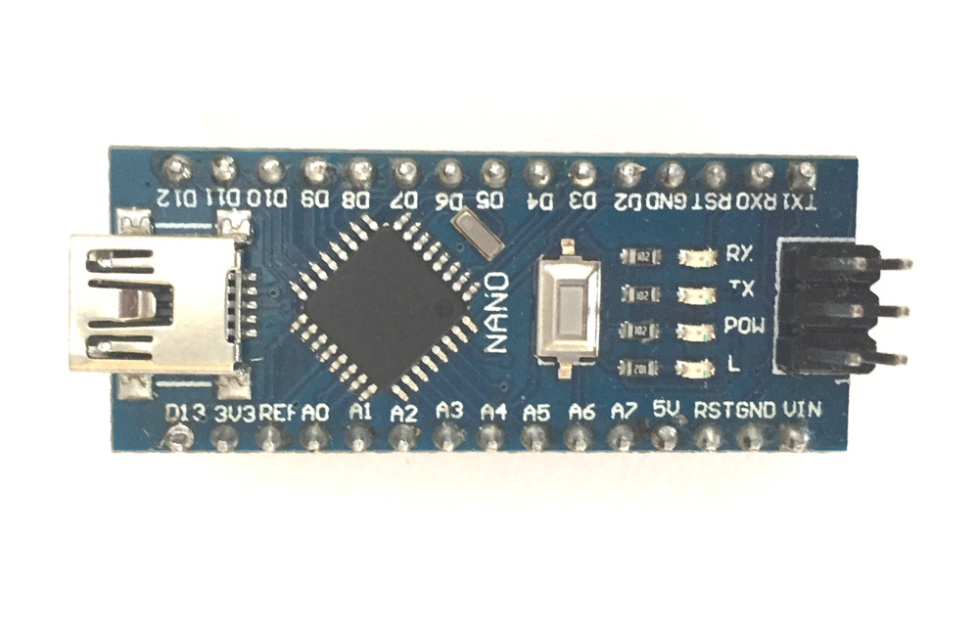

Fig: 1.0 Arduino Nano

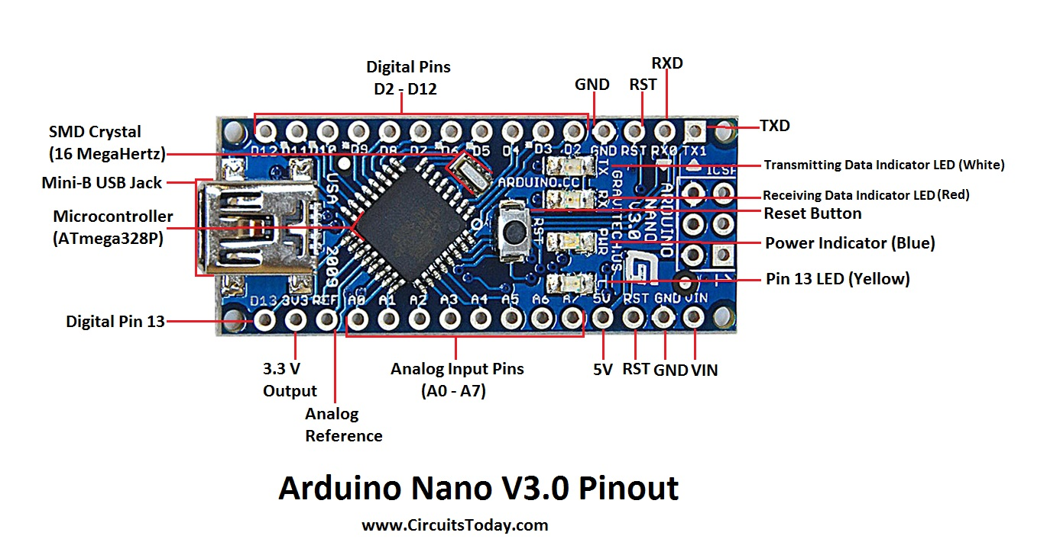

Fig: 1.1Arduino Nano pin out

2.1.1 - PIN DESCRIPTION**:-**

**Arduino Nano Pin Configuration**

|  |  |  |
| --- | --- | --- |
| **Pin Category** | **Pin Name** | **Details** |
| Power | **Vin,**  **5V**  **3.3V**  **GND** | **Vin:** Input voltage to Arduino when using an  External power source (6-12V).  **5V:** Regulated power supply used to power  Microcontroller and other components on the board.  **3.3V:** 3.3V supply generated by on-board  Voltage regulator. Maximum current draw is 50mA.  **GND:** Ground pins. |
| Reset | **Reset** | Resets the microcontroller. |
| Analog Pins | **A0 – A7** | Used to measure analog voltage in the range of 0-5V |
| Input/output Pins | **Digital Pins**  **D0 - D13** | Can be used as input or output pins. 0V (low) and  5V (high) |
| Serial | Rx, **Tx** | Used to receive and transmit TTL serial data. |
| External Interrupts | 2, 3 | To trigger an interrupt. |
| PWM | 3, 5, 6, 9, 11 | Provides 8-bit PWM output. |
| SPI | 10(SS),11 (MOSI), 12 (MISO) and 13 (SCK) | Used for SPI communication. |
| Inbuilt LED | **13** | To turn on the inbuilt LED. |
| IIC | A4(SDA),  A5 (SCA) | Used for TWI communication. |
| AREF | **AREF** | To provide reference voltage for input voltage. |

#### Table 1.0:-pin configuration of Arduino nano

2.1.2- FEATURES**:-**

• It has 22 input/output pins in total.

• 14 of these pins are digital pins.

• Arduino Nano has 8 analogue pins.

• It has 6 PWM pins among the digital pins.

• It has a crystal oscillator of 16MHz.

• It's operating voltage varies from 5V to 12V.

• It also supports different ways of communication, which are:

• Serial Protocol.

• I2C Protocol.

• SPI Protocol.

• It also has a mini USB Pin which is used to upload code.

• It also has a Reset button on it

## 

## 2.2 MQ-135 SENSOR

* MQ-135 is an air quality or air pollution measuring sensor device. It can detect various chemical contents in air and give appropriate voltage variation at the output pin depending on the chemical concentration in air.
* It has 4 pins {VCC, GND, and ANALOG O/P & DIGITAL O/P}.
* It can detect alcohol, Benzene, smoke, NH3, butane, propane etc. if anyone of the stated chemical concentration rises, the sensor convert the chemical concentration in air to appropriate voltage range, which can be processed by Arduino or any microcontroller. It cannot tell what kind of chemical concentration rose in the air**.**

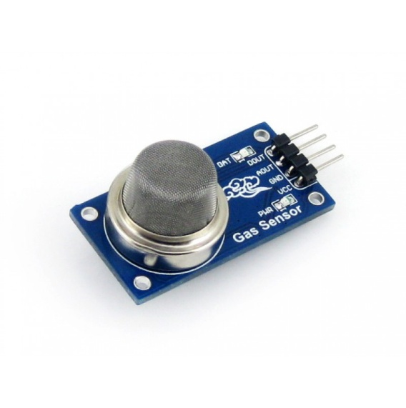

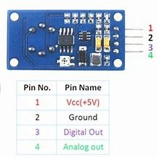

Fig: 1.2 MQ-135 SENSOR Fig: 1.3 MQ-135 pin out

2.2.1- PIN DESCRIPTION**:-**

|  |  |  |
| --- | --- | --- |
| Pin No: | Pin Name: | Description |
| 1 | VCC | Used to power the sensor, Generally the Operating voltage  = +5V. |
| 2 | Ground | Used to connect the module to system ground. |
| 3 | Digital Out | You can also use this sensor to get digital output from this pin,  By setting a threshold value using the potentiometer. |
| 4 | Analog | This pin outputs 0-5V analog voltage based on the intensity  Of the gas. |

#### Table 1.1:- pin configuration of MQ -135 sensor

2.2.2- Features**:-**

* High Sensitivity.
* High sensitivity to NH3, NOX, Ammonia, Sulfide and Benzene.
* Stable and Long Life.
* Detection Range: 10 - 300 ppm NH3, 10 - 1000 ppm Benzene,
* 10 –300 Alcohol.
* Heater Voltage: 5.0V.
* Dimensions: 18mm Diameter, 17mm High excluding pins, Pins - 6mm High.
* Long life and low cost.

## 2.3 LEDS

 Light –emitting diode (LED) is a semiconductor device that emits light when an electric current is passed through it. LED is exceptionally bright with a wide beam angle, so they’re suitable for use in your projects, illuminations, headlamps, spotlights, car lighting, and models. The 5mm LED can be used anywhere where you need low power, high-intensity reliable light, or indication.

Red LED is made using aluminum indium gallium

phosphide (AlInGaP).

Green LED is made using  Indium gallium nitride (InGaN).

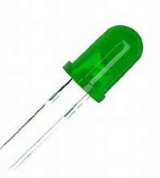 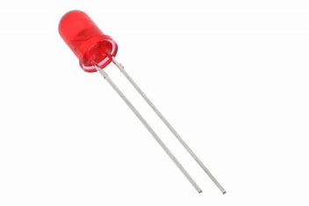

Fig: 1.4 GREEN LED fig: 1.5 RED LED

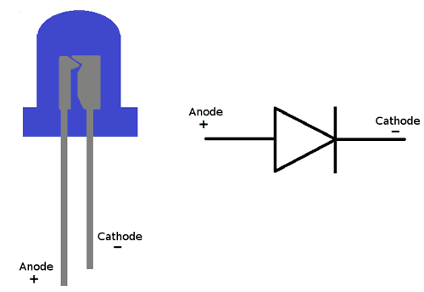

Fig: 1.6 LED pin out

2.3.1 - Pin Description**:-**

|  |  |
| --- | --- |
| Pin Name | Description |
| Anode | Positive terminal of LED |
| Cathode | Negative terminal of LED |

#### Table 1.2:- pin configuration of LED

2.3.2 - Working Principle**:-**

To the energy of the photon) is determined by the energy band gap of the semiconductor. A light-emitting diode is a two-lead semiconductor light source. It is a p–n junction diode that emits light when activated. When a suitable voltage is applied to the leads, electrons are able to recombine with electron holes within the device, releasing energy in the form of photons. This effect is called electroluminescence, and the color of the light (corresponding.

2.3.3 - Features and Technical Specifications**:-**

* Superior weather resistance

* 5mm Round Standard Directivity

* Forward Current (IF): 30mA

* Forward Voltage (VF): 1.8V to 2.4V

* Reverse Voltage: 5V

* Operating Temperature: -30℃ to +85℃

* Storage Temperature: -40℃ to +100℃

* Luminous Intensity: 20mcd

2.3.4 - Advantage**:-**

* Long life.

* Energy efficiency.

* High brightness and intensity.

* Low radiated heat.

* Reliability.

* Exceptional color range.

* Instantaneous illumination.

* Directional lighting.

2.3.5 - Applications**:-**

* TV backlighting.

* Smartphone backlighting.

* LED displays.

* Automotive lighting.

* dimming of lights.

* In mini projects.

## 2.4 BUZZER

A **buzzer**is a small yet efficient component to add sound features to our project/system. It is very small and compact 2-pin structure hence can be easily used on breadboard, Perf Board and even on PCBs which makes this a widely used component in most electronic applications. A buzzer or beeper is an audio signaling device which may be mechanical, electromechanical or piezoelectric (piezo for short). Typical usage of buzzer and beeper include alarm devices, Timers and conformation of user input such as much click or keystroke.

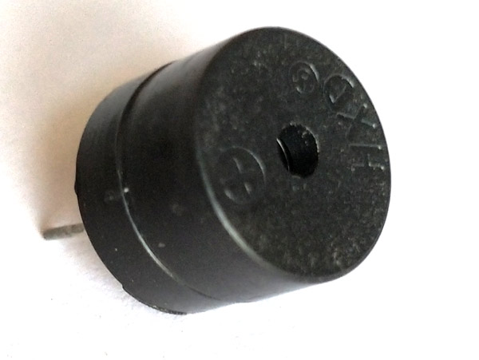

Fig: 1.7 Buzzers

Fig: 1.8 buzzer pin out

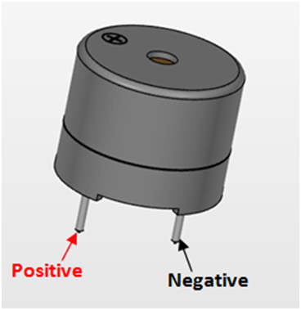

2.4.1 - Buzzer Pin Description**:-**

|  |  |  |
| --- | --- | --- |
| **Pin Number** | **Pin Name** | **Description** |
| 1 | Positive | Identified by (+) symbol or longer terminal lead. Can be powered by 6V DC |
| 2 | Negative | Identified by short terminal lead. Typically connected to the ground of the circuit |

#### Table 1.3:- pin configuration of Buzzer

2.4.2 - Buzzer Features and Specifications**:-**

* Rated Voltage: 6V DC
* Operating Voltage: 4-8V DC
* Rated current: <30mA
* Sound Type: Continuous Beep
* Resonant Frequency: ~2300 Hz
* Small and neat sealed package
* Breadboard and Perf board friendly.

## 2.5 BREAD BOARD

 Breadboard is to make quick electrical connections between components- like resistors, LEDs, capacitors, etc- so that you can test your circuit before permanently soldering it together. Breadboards have many small sockets on them, and some groups of sockets are electrically connected to each other.

It is reusable. This makes it easy to use for creating temporary prototypes and experimenting with circuit design. For this reason, solder less breadboards are also popular with students and in technological education. Order breadboard types did not have this property. A strip board (Vero board) and similar prototyping printed circuit boards, which are used to build semi permanent soldered prototypes or one-offs, cannot easily be reused.

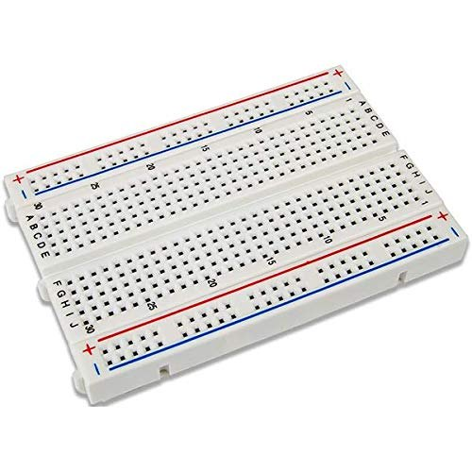

Fig: 1.9 bread board

Note how all holes in the selected row are connected together, so the holes in the selected column. The set of connected holes can be called a node:

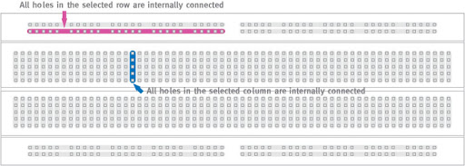

**Fig 2.0 (a):** Internal structure of breadboard

To interconnect the selected row (node A) and column (node B) a cable going from any hole in the row to any hole in the column is needed:

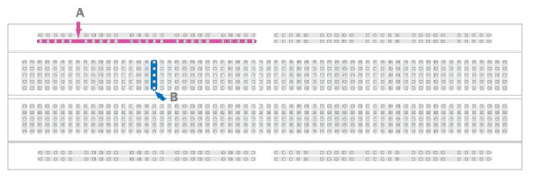

**Fig 2.0 (b):** serial connection

Now the selected column (node B) and row (node A) are interconnected.

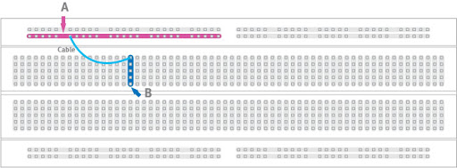

**Fig 2.0 (c):** Parallel connection

## 2.6 CONNECTING WIRES & JUMPER WIRES

### 2.6.1 – SINGLE STAND CONNECTING WIRES

A wire is a single, usually cylindrical, flexible strand or rod of metal. Wires are used to bear mechanical loads or electricity and telecommunications signals. Wire is commonly formed by drawing the metal through a hole in a die or draw plate. Wire gauges come in various standard sizes, as expressed in terms of a gauge number. The term wire is also used more loosely to refer to a bundle of such strands, as in "multi-stranded wire", which is more correctly termed a wire rope in mechanics, or a cable in electricity. Connecting wires can be made from aluminum and other materials almost all electrical wires are made of copper.

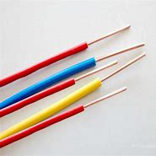

Fig: 2.1 single stand wires

### 2.6.2 - JUMPERWIRES

A jumper wire is an electrical wire, or group of them in a cable, with a connector or pin at each end (or sometimes without them - simply "tinned"), which is normally used to interconnect the components of a breadboard or other prototype or test circuit, internally or with other equipment or components, without soldering . Individual jump wires are fitted by inserting their "end connectors" into the slots provided in a breadboard, the header connector of a circuit board, or a piece of test equipment.

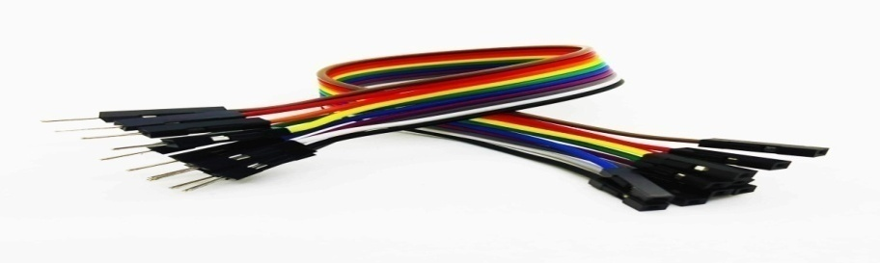

Fig: 2.2 Jumper wires

**2.6.2 (a) Types**

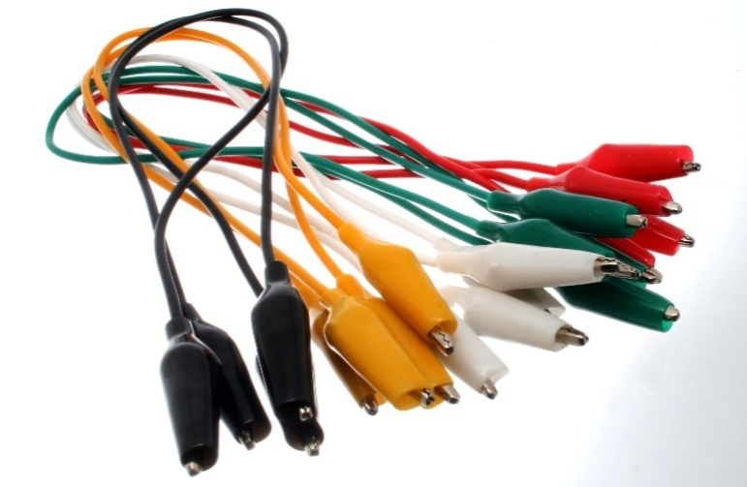

**Fig 2.2 (a):** Jumper wires with crocodile clips.

Jump wires at the end of a multi-colored ribbon cable are used to connect the pin header at the left side of a blue USB2Serial board to a white breadboard below.

Another jumper cable ending in a USB micro male connector mates to the right side of the USB 2 Serial board. Red and black tinned jump wires can be seen on the breadboard.

There are different types of jumper wires. Some have the same type of electrical connector at both ends, while others have different connectors. Some common connectors are:

1. Solid tips – are used to connect on/with a breadboard or female header connector. The arrangement of the elements and ease of insertion on a breadboard allows increasing the mounting density of both components and jump wires without fear of short-circuits. The jump wires vary in size and color to distinguish the different working signals.

2. Crocodile clips – are used, among other applications, to temporarily bridge sensors, buttons and other elements of prototypes with components or equipment that have arbitrary connectors, wires, screw terminals, etc.

3. Banana connectors – are commonly used on test equipment for DC and low-frequency AC signals.

4. Registered jack (RJnn) – are commonly used in telephone (RJ11) and computer networking (RJ45).

5. Which is used to connect antennas and other components to network cabling? Jumpers are also used in base stations to connect antennas to radio units. Usually, the most bendable jumper cable diameter is 1/2"RCA connectors – are often used for audio, low resolution composite video signals, or other low-frequency applications requiring a shielded cable.

6. RF connectors – are used to carry radio frequency signals between circuits, test equipment, and antennas.

7. RF jumper cables Jumper cables are a smaller and more bendable corrugated cable.

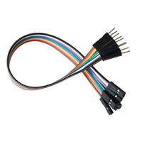 **Fig 2.2 (b):** male to female connectors.

A connector type with pins instead of holes. These connectors are inserted into a female connector. Good examples of **male connectors** are power plugs and coaxial cables. In the example picture, the power cord connector on the left-side with holes is a female connector, and on the right-side with pins that connects to the wall outlet is a male connector.

A female connector is a connector attached to a wire, cable, or piece of hardware, having one or more recessed holes with electrical terminals inside, and constructed in such a way that a plug with exposed conductors (male connector) can be inserted snugly into it to ensure a reliable physical and electrical connection. A female connector is also known as a jack, outlet, or receptacle. This type of connector can be recognized by the fact that, when it is disconnected therefore is not likely to make accidental contact with external objects or conductors.

The most common female connector is a two- or three-prong electrical outlet, also known as a wall outlet. Other often-encountered examples include telephone jacks, the jacks for headsets, the chassis connectors for coaxial cable, and some D-shell connectors for computer serial and parallel port s

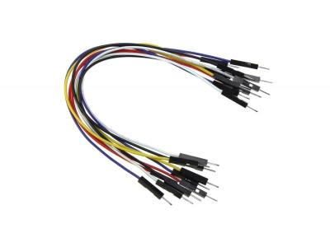

**Fig 2.2 (c):** male to male connector

## 2.7 9V BATTTERY

* The Hi Watt 9V battery is an affordable, reliable, dedicated low-power solution to provide sufficient energy to your circuit. Ideally used in circuits with low power consumption so that it can work for longer durations.
* These batteries are used in toys, in alarms, in mini projects and households.

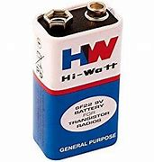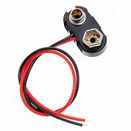

Fig: 2.3 9v battery WITH CONNECTOR

The battery has both terminals in a snap connector on one end. The smaller circular (male) terminal is positive, and the larger hexagonal or octagonal (female) terminal is the negative contact. The connectors on the battery are the same as on the load device; the smaller one connects to the larger one and vice versa. The snap-style connector is used.

# CHAPTER 3

# SOFTWARE DESCRIPTIOIN

Step 1 − First you must have your Arduino board (you can choose your favorite board) and a USB cable. In case you use Arduino UNO, Arduino Duemilanove, Nano, Arduino Mega 2560, or Decimal, you will need a standard USB cable (A plug

## USB Type A to USB Type B Cable Adapter Printer Cable | Shopee Philippines

**Fig 2.4:** A to B connector

**Step 2 −** Download Arduino IDE Software.

You can get different versions of Arduino IDE from the Download page on the Arduino Official website. You must select your software, which is compatible with your operating system (Windows, IOS, or Linux). After your file download is complete, unzip the file.

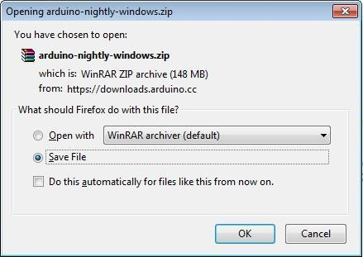

**Fig 2.5:** Downloading Arduino IDE

**Step 3** − Power up your board.

The Arduino Uno, Mega, Duemilanove and Arduino Nano automatically draw power from either, the USB connection to the computer or an external power supply.

If you are using an Arduino Diecimila, you have to make sure that the board is configured to draw power from the USB connection. The power source is selected with a jumper, a small piece of plastic that fits onto two of the three pins between the USB and power jacks. Check that it is on the two pins closest to the USB port. Connect the Arduino board to your computer using the USB cable. The green power LED (labeled PWR) should glow.

**Step 4** − Launch Arduino IDE.

After your Arduino IDE software is downloaded, you need to unzip the folder. Inside the folder, you can find the application icon with an infinity label (application.exe). Double click the icon to start the IDE.

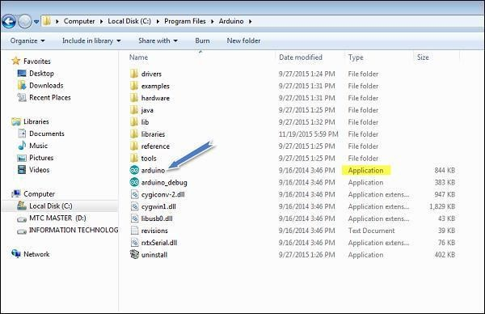

**Fig 2.6**: launch Arduino IDE

**Step 5 −** Open your first project.

Once the software starts, you have two options –

* Create a new project.
* Open an existing project example.

To create a new project, select File → new.

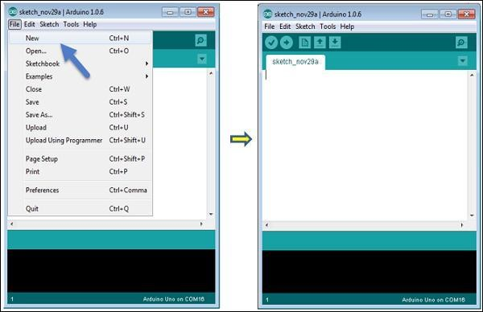

**Fig 2.7:** to create a new project

To open an existing project example, select File → Example → Basics → Blink.

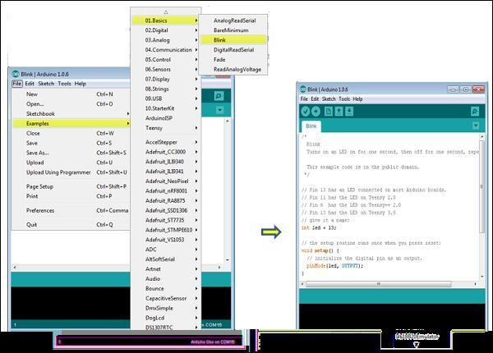

**Fig 2.7(a):** Opening project

Here, we are selecting just one of the examples with the name Blink. It turns the LED on and off with some time delay. You can select any other example from the list.

**Step 6** − Select your Arduino board.

To avoid any error while uploading your program to the board, you must select the correct Arduino board name, which matches with the board connected to your computer.

Go to Tools → Board and select your board.

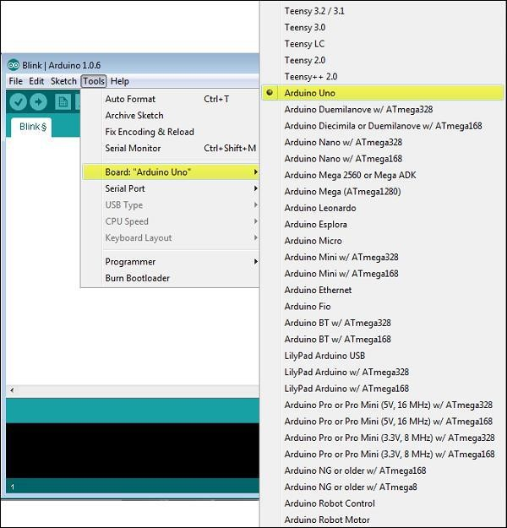 Fig 2.8: Selecting Arduino board

Here, we have selected Arduino Uno board according to our tutorial, but you must select the name matching the board that you are using.

**Step 7** − Select your serial port.

Select the serial device of the Arduino board. Go to Tools → Serial Port menu. This is likely to be COM3 or higher (COM1 and COM2 are usually reserved for hardware serial ports).

To find out, you can disconnect your Arduino board and re-open the menu, the entry that disappears should be of the Arduino board. Reconnect the board and select that serial port.

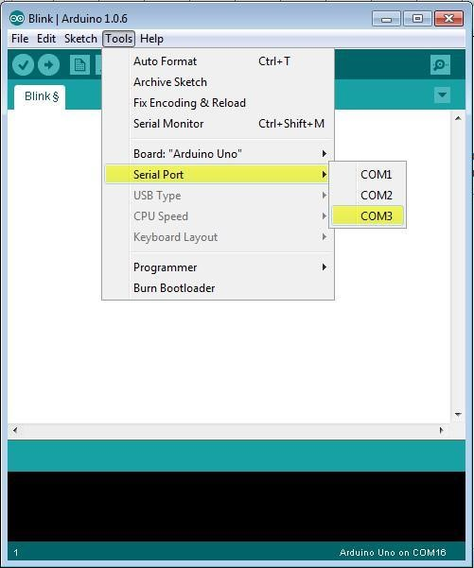

Fig 2.9: serial port selection

**Step 8**−Upload the program to your board.

Before explaining how we can upload our program to the board, we must demonstrate the function of each symbol appearing in the Arduino IDE toolbar.

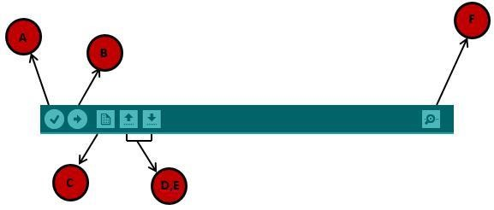

FIG 3.0: uploading program

1. − Used to check if there is any compilation error.
2. − Used to upload a program to the Arduino board.
3. − Shortcut used to create a new sketch.
4. − Used to directly open one of the example sketches.
5. − Used to save your sketch.
6. − Serial monitor used to receive serial data from the board and send the serial data to the board.

Now, simply click the "Upload" button in the environment. Wait a few seconds; you will see the RX and TX LEDs on the board, flashing. If the upload is successful, the message "Done uploading" will appear in the status bar.

Note − If you have an Arduino Mini, NG, or other board, you need to pressthe reset button physically on the board, immediately before clicking the upload button on the Arduino Software.

# CHAPTER 4

# WORKING

LED

BUZZER

ARDUINO NANO

**POWER SOURCE**

MQ-135 SENSOR

FIG 3.1: BLOCK DIAGRAM

4.1 BLOCK DIAGRAM EXPLANATION**:-**

* The proposed system consists of Arduino Nano. It is interfaced to sensor i.e., Mq-135 sensor, buzzer and LEDS.

* Here Arduino nano is the heart of the system, which is programmed.

* MQ-135 sensor is designed for detecting the LPG gas, smoke, and benzene….soon.

* Buzzer is an audio signaling device.

* LEDS is a light emitting device and here we use red & green LEDs are used.

* The method takes an automatic control action upon detection of gas.

* Initially if there is a gas leakage and when sensor detects it, then the output of it goes high.

* This signal is sensed by Arduino Nano.

* Then Arduino nano will produce an output signal which is fed to buzzer and LED which makes them ON.

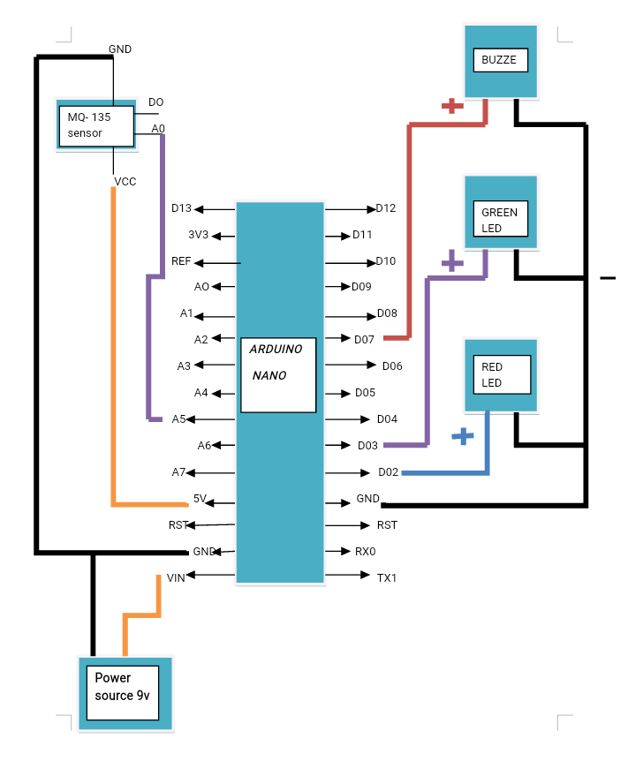

FIG 3.2: CIRCUIT DIAGRAM

## 4.2 CIRCUIT EXPLANATION

•The A0 pin of MQ-135 sensor is connected to the Address line-5(A5) (pin-21) of Arduino Nano.

•The power supply pins VCC and GND of MQ-135 sensor are connected to the 5V and GND (Pin-27 & Pin-29) of Arduino Nano.

•The power source of 9V positive terminal is connected to the VIN (pin-30) of Arduino Nano and the negative terminal is grounded.

•The positive terminal of buzzer is connected to the D07 (Pin-10) of Arduino Nano.

•The positive terminal of Red LED is connected to the D03 (Pin-6) of Arduino Nano.

•The positive terminal of Green LED is connected to the D02 (Pin-5) of Arduino Nano.

•The negative terminal of Buzzer, Red LED and Green LED are commonly grounded.

## 4.3 WORKING

When the power supply is applied the circuit will start working i.e., indicated by the green LED as it starts glowing. As we know MQ-135 sensor is connected to Arduino nano. The MQ5 sensor gas module has 4 pins. Two pins are used for interfacing with development board and other two pins are VCC and ground. Out of two interfacing pins one pin is analog output and other is digital pin. The analog output pin of the module is used for detecting concentration level of gas leakage and interfaced with the A5 analog input pin of the Arduino nano. So when the sensor detects LPG gas it produces a high output signal which is given to Arduino nano (from pin AO of sensor to A5 pin of Arduino nano). As for the program installed in it, an output signal is produced which will make the green LED connected to Arduino nano at pin D03 to go off and red LED at pin D02, BUZZER at pin D07 to get ON. This indicates the LPG gas leakage has taken place.

## 4.4 ADVANTAGES

* It is used in houses as LPG leakage detection.

* It also detects alcohol so it is used as liquor tester.

* The sensor has excellence sensitivity combine with a quick response of time.

* Detection and prevention of any sort of gas leakage.

* Cost efficient

* Less complex circuit.

* No environmental effect on the circuit.

* It can be used in LPG stores, at gas stations as LPG gas leakage detecting alarm, which reduces the huge loss of property and life.

## 4.5 APPLICATIONS

* it can be used in households,

in LPG gas stations,

in restaurant’s and

in malls as safety alarm device.

# CHAPTER 5

# RESULT

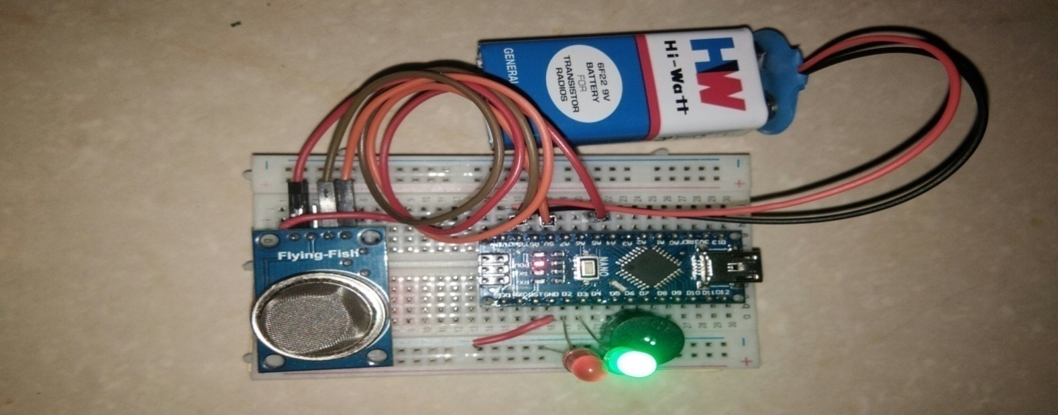

FIG 3.3 – CIRCUIT CONNECTION

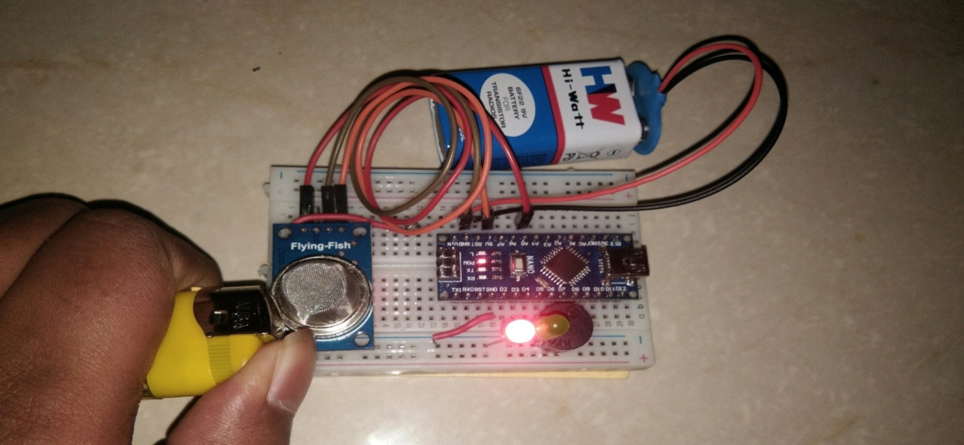

FIG 3.4 – OUTPUT OF THE PROJECT

# CHAPTER 6

# CONCLUSION & FUTURE SCOPE

6.1 CONCLUSION**:-**

Gas leakage may leads to severe accidents which results in material losses and human injuries. Gas leakage occurs mainly due to poor maintenance of equipments and inadequate awareness of the people. Hence LPG leakage detection will be helpful to prevent accidents and to save human lives. This project presented LPG leakage detection and alert system. This system triggers buzzer to alert people when LPG leakage is detected. This system is very single yet reliable.

6.2 FUTURE SCOPE**:-**

The further scope of improvement can be like: Battery used in this system is of 9V which is not that much sufferable, in future improvement, we can use a bigger, rechargeable one, which can sustain the gas detection module for a long period of time, with warning signal whenever battery runs out' In further modification, in addition to only leakage detection we can make message sending to our mobile. The project has a good viability to be launched in commercial market, small scale industries having multiple cylinders stored. with further improvement in design the system can be made more handy and cost effective for the users.

# CHAPTER 7

# APPENDIX

# SOFTWARE REQUIREMENTS

int redLed = 2;

int greenLed = 3;

int buzzer = 7;

int smokeA0 = A5;

// Your threshold value

int sensorThres = 400;

void setup() {

pinMode(redLed, OUTPUT);

pinMode(greenLed, OUTPUT);

pinMode(buzzer, OUTPUT);

pinMode(smokeA0, INPUT);

Serial.begin(9600);

}

void loop() {

int analogSensor = analogRead(smokeA0);

Serial.print("Pin A0: ");

Serial.println(analogSensor);

// Checks if it has reached the threshold value

if (analogSensor > sensorThres)

{

digitalWrite(redLed, HIGH);

digitalWrite(greenLed, LOW);

tone(buzzer, 3000, 300);

}

else

{

digitalWrite(redLed, LOW);

digitalWrite(greenLed, HIGH);

noTone(buzzer);

}

delay(100);

}

# CHAPTER 8

# REFERENCES

* <https://create.arduino.cc/projecthub/shashwatraj98765/how-to-make-gas-leak-alert-security-alarm-using-arduino-02e099>

* <https://techatronic.com/gas-leakage-detector-using-arduino-lpg-alarm/>

* <https://components101.com/microcontrollers/arduino-nano>

* <https://www.codrey.com/electronic-circuits/how-to-use-mq-135-gas-sensor/>

* <https://components101.com/buzzer-pinout-working-datasheet>

* <https://en.wikipedia.org/wiki/Jump_wire>